Environment, Wildlife, and Conservation in Oman
In this module, students will learn about the diversity of plants and animals found in the Sultanate of Oman. Oman has a variety of climates and ecosystems within its small boundaries, which fosters great conditions for thriving biodiversity. In addition to mammals, Oman has over 400 plant species, over 500 bird species, and extremely rich marine life. Unfortunately, many of Oman's native species have become endangered. The IUCN Red List compiles plant and animal species around the world whose populations are so low they are at risk of extinction. Nature reserves and other conservation efforts are now in place to protect and support the plants and animals of Oman.

Environment
While over 80% of the Sultanate of Oman is desert and valleys (wadi), its varied landscape also includes mountains, beaches, plains, and caves. Oman is home to the world's largest sand desert (Rub' al Khali or The Empty Quarter), as well as the highest mountains in the eastern Arabian Peninsula (Al Hajar Mountains). There is lush greenery nestled between mountain ranges and coastlines in the Dhofar region as well as in the North near the capital city of Muscat. The summer monsoon of the Indian Ocean drastically changes the Dhofar region's (located in south west Oman) environment each summer. The warm winds of the summer blow in monsoon rains, transforming the landscape to a vivid green. There are also picturesque fjords and caves on the Musandam Peninsula near the Strait of Hormuz. Lastly, the Al Dimaniyyat Nature Reserve protects a diversity of marine life around the archipelago of Islands on the northern coast.

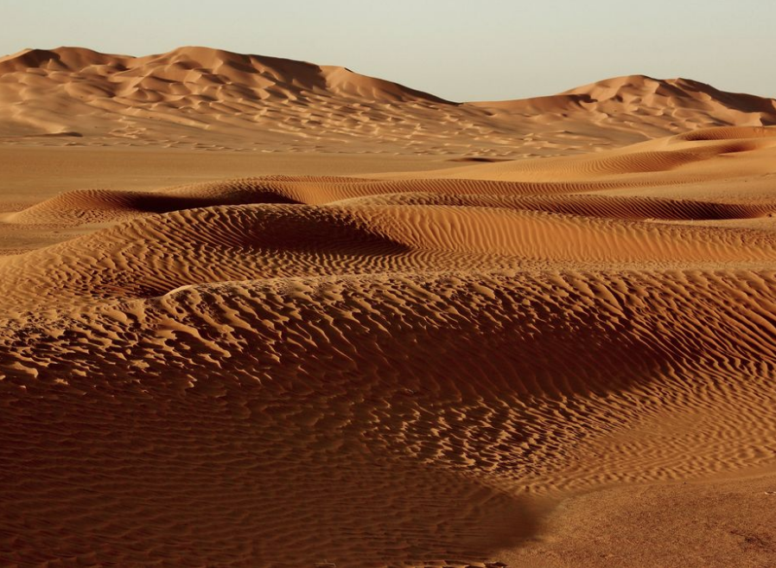
Rub Al Khali desert in Oman
https://yourshot.nationalgeographic.com/photos/9210093/

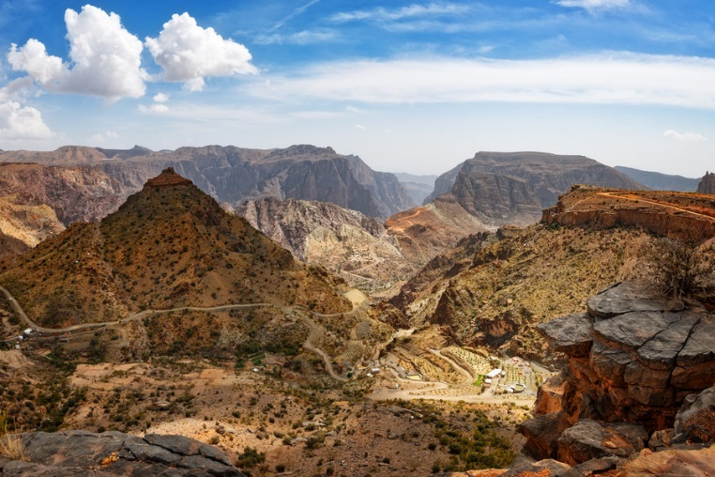
Oman's Hajar mountain range
https://www.departures.com/travel/oman-hotels-things-to-do

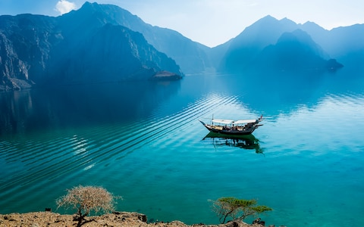
The fjords of Khasab
https://www.telegraph.co.uk/travel/beautiful-oman/holidays-on-the-cost/

Wildlife
Each of these ecosystems makes a fitting habitat for a wide array of wildlife. Oman's most famous fauna includes the Arabian leopard, humpback dolphin, dromedary camel, the Arabian oryx, and sea turtles. Oman's six protected areas and nature reserves for these creatures cover an area of almost 30,000 square kilometers.

The Arabian Leopard
The Arabian Leopard, native to the Arabian Peninsula, is a critically endangered subspecies. Their numbers continue to decline due to habitat loss and fragmentation, as well as overhunting. The last survey of the population, conducted in 2006, noted that there were believed to be less than 200 individuals in the world. It is believed that roughly 10% of all remaining Arabian leopards live in Oman. In Oman they roam one of the last refuges for wild Arabian leopards in the world: the Jabal Samhan reserve in the Dhofar mountain range.
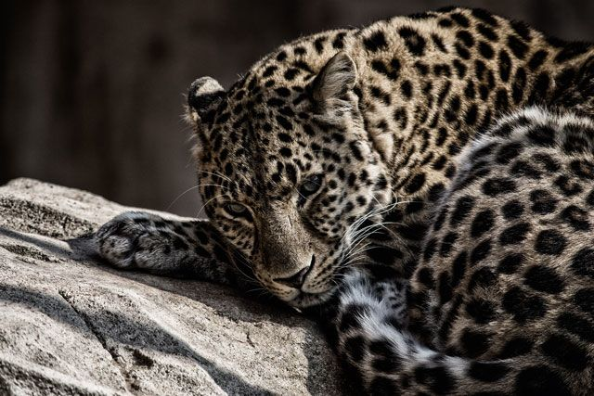
Arabian Leopard
https://www.nationalgeographic.co.uk/travel/2018/10/dhofar-where-leopards-roam

Humpback Dolphins
The Fjords of Musandam near the port city of Khasab are home to Indian Ocean humpback dolphins -- another endangered species. The dolphins live and travel in groups of up to 12, and only dwell in shallow waters up to 20 meters. They are incredibly playful and social, and are known for their big personalities. They face endangerment due to anthropogenic (human-related) disturbances such as fishing, chemical and noise pollution, and habitat destruction.

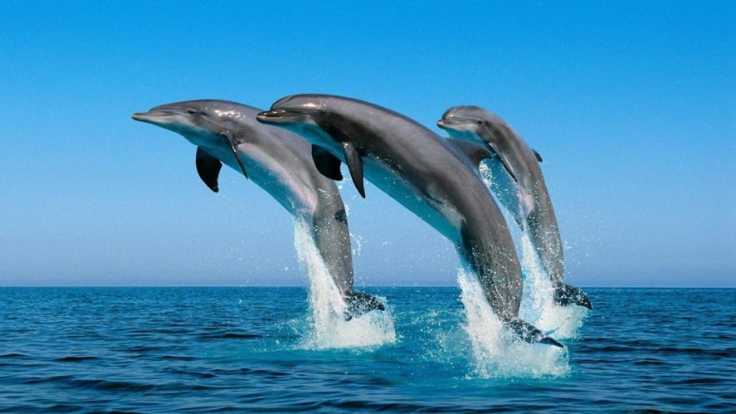
Indian Ocean Humpback Dolphins in Oman
https://timesofoman.com/article/100890

Dromedary Camels
The camel is perhaps the Middle East's most famous animal and is often called 'the ship of the desert.' Camels can carry 150 to 250 kilograms (about 500 pounds), travel for days without water, and eat wild desert vegetation. Dromedary camels are known for their characteristic hump (Bactrian camels, characterized by their double hump, come from central Asia). Dromedary camels are native to the Arabian Peninsula and were first domesticated up to 6000 years ago. In addition to transportation, they are used for their wool, milk, meat, and leather. Camels also play a key role in many cultural activities in the Sultanate, like camel racing. In Oman, camels live primarily in the Sharqiya Sands desert region (along the eastern coast between Muscat and Sur).

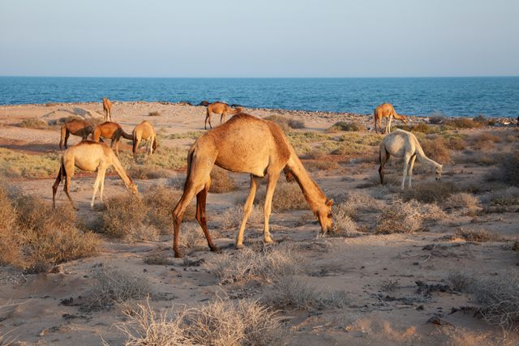
Camels in the Sharqiya Sands
https://www.nationalgeographic.co.uk/travel/2018/10/wildlife-where-spot-omans-big-five

Arabian Oryx
The Arabian oryx, or white oryx, is native to Oman and the Arabian Peninsula. By the 1970s, the oryx was extinct in the wild due to overhunting. However, after sustained conservation efforts, the Arabian oryx was repopulated in captivity and eventually reintroduced in to the wild. In 2011, the oryx's status was upgraded from endangered to vulnerable status after successful conservation efforts. The animals have huge ranges, a herd of oryx in Oman can cover over 3,000 square kilometers. The Al Wusta Wildlife Reserve in Oman's central desert acts as both an oryx sanctuary and breeding ground.

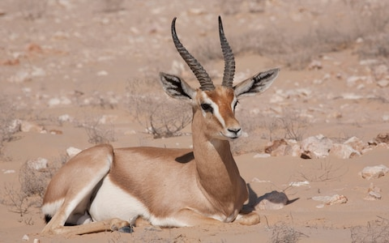
A breeding ground of Oryx at the Al Wusta Wildlife Reserve
https://www.telegraph.co.uk/travel/beautiful-oman/nature-watching/

Nubian Ibex
The Nubian ibex is a species of goat that live in mountainous regions across the Middle East and North Africa. They eat mainly grasses and leaves in their dry terrain, and are hunted by leopards, wolves, and sometimes vultures. The ibex is classified as vulnerable on the IUCN Red List. Their shiny coats reflect the intense sunlight of their desert habitat and are waterproof to repel raindrops. They are also incredibly agile, and can climb steep cliffs with ease to avoid predators.
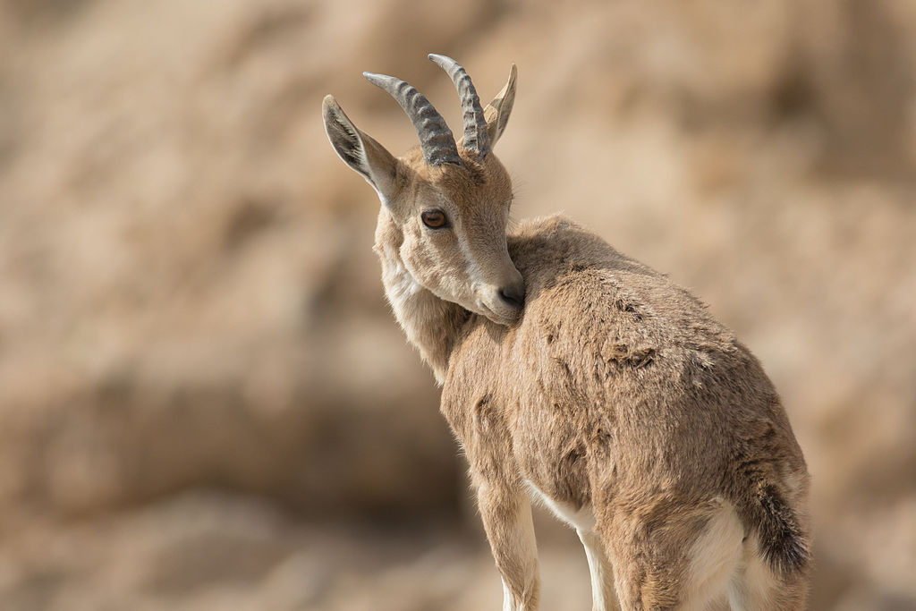
Young Nubian Ibex in Sde Boker
https://en.wikipedia.org/wiki/Nubian_ibex#/media/File:Capra_nubiana,_Israel_15.jpg

Sooty Falcon
The sooty falcon is a medium-sized bird of prey native to the Middle East. Their broad range stretches from Madagascar through North Africa all the way to Northern Oman. In Oman, they live in the northern part of the country near the Gulf of Oman and are considered vulnerable according to the IUCN Red List. The sooty falcon migrates very long distances, often traveling the length of Africa between wintering and breeding. Unlike most other falcon species, they sometimes nest in colonies.
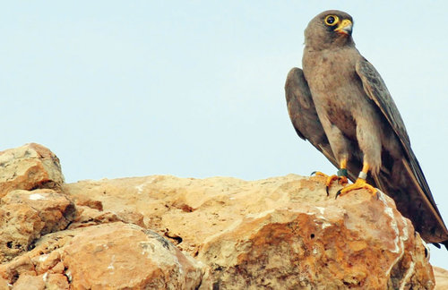
Sooty Falcon in Oman
https://muscatdaily.com/Archive/Oman/Sooty-falcon-s-epic-journey-between-sultanate-and-Madagascar-mapped-3cuf

Sea Turtle Conservation
Sea turtles have become a symbol for conservation efforts in Oman. For over 100 million years, sea turtles have traveled great distances across the world's oceans fulfilling a crucial role in the balance of marine ecosystems. There are seven species of sea turtles in the world and four of them frequent Omani beaches to nest: the green turtle, the loggerhead turtle, the hawksbill turtle, and the olive ridley turtle. A fifth species, the leatherback turtle, does not nest in Oman but does live in its waters. Oman is home to the world's largest nesting population of green turtles, and Masirah Island has one of the largest populations of nesting loggerhead turtles. Green turtles are one of the few marine turtles known to leave the water other than at nesting times. Seeing green turtles on the beaches of Oman attracts tourists from around the world.
All sea turtle species migrate between feeding and nesting grounds, taking them hundreds and sometimes thousands of miles. With satellite telemetry, scientists can track the movements of sea turtles between areas and even across entire oceans. Unfortunately, all seven species of sea turtles are classified as critically endangered (hawksbill), endangered (green), or vulnerable (olive ridley, leatherback, and loggerhead) on the IUCN red list.
Sea turtles face a variety of endangerment risks. Green sea turtles face poaching and exploitation, and have been hunted for their meat, eggs, skin, and shells since the early 20th century. Turtle meat and eggs are considered a delicacy in many different cultures across the world. This cultural culinary legacy translates to a continued high demand for sea turtles, despite international bans and protections. Sea turtles also become bycatch (the unwanted marine creatures caught accidentally in commercial fishing), and die after entanglement in nets. Global warming also affects sea turtle populations in multiple ways. As ice caps melt and sea levels rise, turtle nests on beaches are flooded, destroying countless nests and turtle clutches. As temperatures rise, the temperature of nests will rise and affect the sex of hatchlings. Feminization of turtles occurs because warmer nests lead to female turtles being born while cooler ones yield male hatchlings. This could lead to unbalanced gender numbers, which in turn could threaten future breeding prospects. Lastly, infrastructure expansion (buildings, roads, etc.) along coastlines can lead to beach erosion and the destruction of nesting habitats.
There are several conservation organizations working in Oman to protect these endangered species, namely the Environment Society of Oman (ESO), Five Oceans Environmental Services, and the Marine Research Foundation. These groups aim to raise awareness about the impact of human activities on turtle nesting grounds and educate about conservation efforts on an individual level. They also work closely with government stakeholders such as the Ministry of Environment and Climate Affairs and the Ministry of Agriculture and Fisheries Wealth. Conservation activities can also have tangible economic benefits for local residents; for example, ESO's Turtle Research and Conservation project on Masirah Island primarily employs local residents. The Ras al Jinz Turtle Reserve was established in 2008 as an eco-tourism project whose revenue helps conserve green turtle nests. Leaders in sea turtle conservation in Oman are hopeful about the prospects of the species' revival and look to the successes of similar historical efforts.

Conclusion
The Sultanate of Oman is committed to the protection of its diverse collection of flora and fauna. Sustained conservation efforts are critical to the protection of its environment and the protection of its biodiversity. The Sultanate is a signatory on multiple treaties that address global environmental issues. Additionally, natural resources and environmental sustainability are a national priority to plans for development. The Sultanate of Oman is committed to ensuring that future generations experience its natural beauty and can spread the importance of biodiversity to other countries around the world.

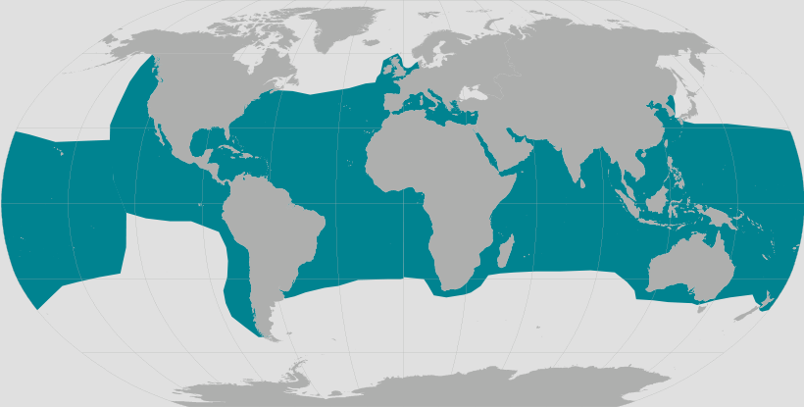
World map providing approximate representation of the Green Turtle's range
https://www.fisheries.noaa.gov/species/green-turtle

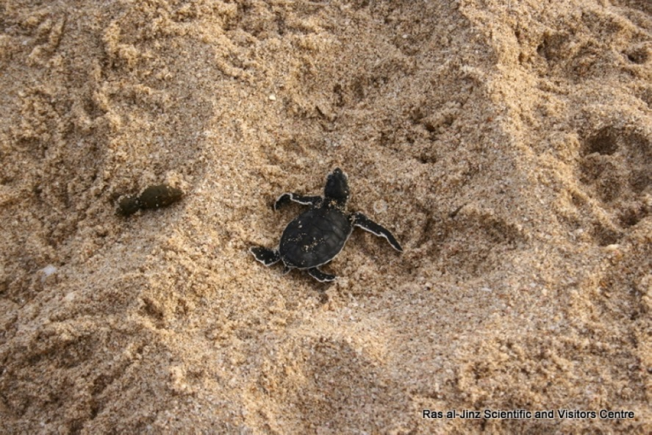
https://timesofoman.com/article/126860
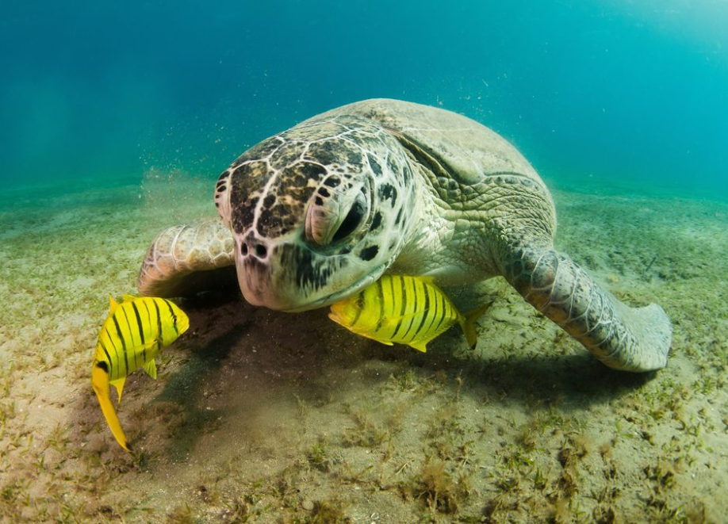
Green Turtle in the Southern Red Sea
https://yourshot.nationalgeographic.com/photos/2387735/
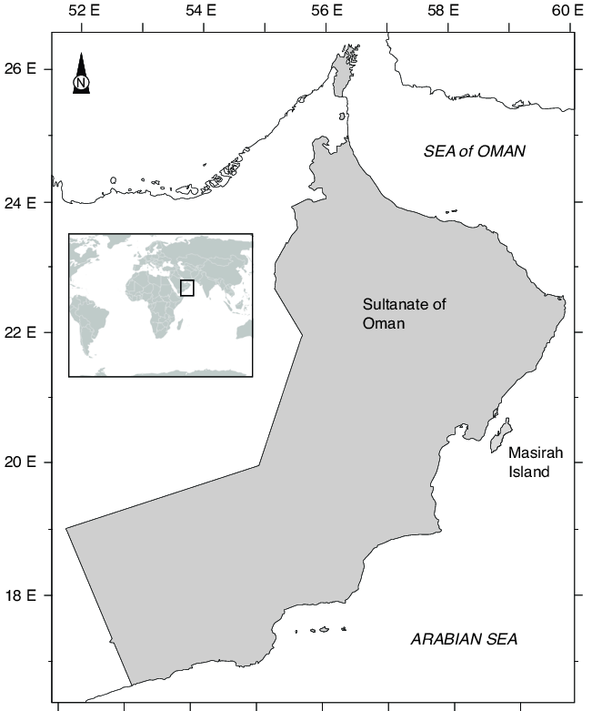
Map of Oman and Masirah Island
https://www.researchgate.net/figure/Map-of-Sultanate-of-Oman-including-with-the-sampling-Masirah-Island-source-MNE-2004_fig1_330362232

References
“Green Sea Turtle.” National Geographic, 24 Sept. 2018, www.nationalgeographic.com/animals/reptiles/g/green-sea-turtle/
“Green Turtle.” WWF, World Wildlife Fund, www.worldwildlife.org/species/green-turtle.
Hunter, Joanna. “Nature-Watching in Oman.” Travel, The Telegraph, 6 Jan. 2017, www.telegraph.co.uk/travel/beautiful-oman/nature-watching/
“Infographic: Sea Turtles.” WWF, World Wildlife Fund, www.worldwildlife.org/pages/infographic-sea-turtles
Lerwill, Ben. Dhofar: Where Leopards Roam. National Geographic, 30 Apr. 2019, www.nationalgeographic.co.uk/travel/2018/10/dhofar-where-leopards-roam
Maniyar, Maqsood. “Save the Turtles.” T-Mag Recreation, Times of Oman, 24 Jan. 2018, timesofoman.com/article/126860
"Rub Al Khali, Empty Quarter of the Arabian Desert." 25 April, 2017. https://www.worldatlas.com/articles/rub-al-khali-empty-quarter-of-the-arabian-desert.html
“Sea Turtle.” WWF, World Wildlife Fund, www.worldwildlife.org/species/sea-turtle
Stein, A.B., Athreya, V., Gerngross, P., Balme, G., Henschel, P., Karanth, U., Miquelle, D., Rostro-Garcia, S., Kamler, J.F., Laguardia, A., Khorozyan, I. & Ghoddousi, A. 2016. Panthera pardus (errata version published in 2016). The IUCN Red List of Threatened Species 2016, https://www.iucnredlist.org/species/15954/102421779
Times News Service. “Another Stage of Turtle Conservation Project in Oman Completed.” Times of Oman, Oman Environment, 18 June 2017, timesofoman.com/article/111525
Wildlife: Where to Spot Oman's Big Five. National Geographic, 30 Apr. 2019, www.nationalgeographic.co.uk/travel/2018/10/wildlife-where-spot-omans-big-five.
“Sooty Falcon.” International Union for Conservation of Nature Red List, 1 October, 2017,
https://www.iucnredlist.org/species/22696446/119400295
“Nubian Ibex: Capra nubiana.” San Diego Zoo Animals and Plants,
https://animals.sandiegozoo.org/animals/nubian-ibex
“Sooty Falcon Falco concolor.” BirdLife International,
http://datazone.birdlife.org/species/factsheet/22696446
Activity 1: Where the Wild Things Are
- Display the map of Omani wildlife on the board. Go over each of the animals and review their characteristics from the background information.
- After spending 10-15 minutes reviewing the animals, distribute the worksheets so the students can match the animals to their habitats.
- After the students complete the matching activity, ask the students why they think each animal prefers to leave in that specific region of Oman.
- Highlight the differences in climate from one area to another.

Sea Turtle Activity Instructions
This activity is meant to accompany the Environment, Wildlife, and Conservation in Oman handout from sqcc.org. Make sure that students have learned the material on pages 6-7 of the handout. Focus on the background information about sea turtles, their significance in Oman, and the importance of conservation efforts.
Click here to view the sea turtle crafting video! Or use the link below:
https://youtu.be/e4yBdnSU4Wk
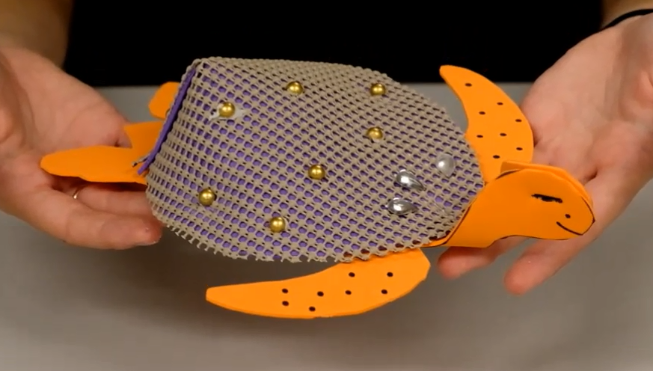

Materials
- 2 foam sheets or pieces of thick construction paper (per turtle)
- 1 square of shelf liner/mesh cloth (per turtle)
- Scissors
- Glue
- Markers
- Stapler
- Scotch tape
- Plastic jewels or rhinestones

Directions
- Print turtle and shell stencils from sqcc.org on cardstock and cut them out
- Tape the turtle stencil onto one of the foam sheets
- Trace the outline with a marker and cut it out
- Tape the shell stencil onto the shelf liner/mesh cloth and trace the outline with a marker
- Tape the shell stencil onto the other foam sheet and trace the outline with a marker
- Cut out the two shells
- Glue the shelf liner/mesh cloth shell onto the foam shell
- Use scissors to make a 2 inch cut on the bottom of the shell
- Fold the two sides along the cut over each other and staple to secure the fold
- Fold the two sides of the turtle head together and staple
- Staple the shell on top of the turtle’s body
- Draw a face onto the turtle with a marker
- Decorate the shell with jewels, rhinestones, or whatever else you want!

The International Union for Conservation of Nature and Natural Resources' Red List of Threatened Species, established in 1964, is considered the world's most comprehensive source on global conservation status of animal, fungi, and plant species.
The Rub' Al Khali desert is the largest sand desert in the world. It stretches over portions of Oman, Saudi Arabia, the United Arab Emirates, and Yemen.

